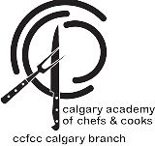

**CACC CHUCKWAGON CHILI COOK OFF**

**AT THE**

**BAR U RANCH**

Bar U Ranch is a National Historic Site which commemorates the importance of ranching in Canada.

**Come out for a day of Canadian food heritage and fun and stay to cheer on our chefs at the**

**BAR U Ranch Chuckwagon Chili Cook Off!**

**This event will coincide with the BAR U annual Chore Horse Competition. See the wagon drivers compete in this prestigious skills competition.**

**When:** Sunday September 21, 2025, 11 am – 2 pm

**Where:** Bar U Ranch - Highway 22 and Highway 540, Longview, AB

**Admission:** Adult $13.25, Senior $11.25, Youth (6 to 17 years old) Free

